# **Caesar Cipher**

Output:

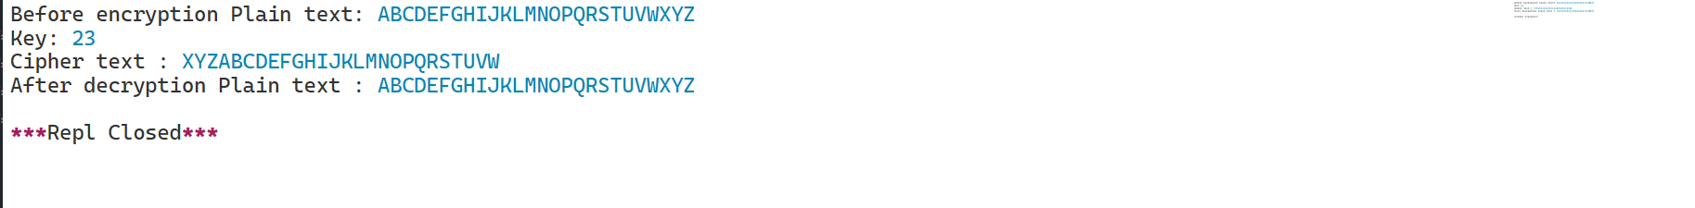

# **Playfair Cipher**

Output

Git-hub link : <https://github.com/PrashanthSingaravelan/winter_semester-2022/tree/main/CSI3002%20Applied%20Cryptography%20and%20Network%20Security/lab%20exercises>